‘House Rules’
- Stay on Unreal Engine 4.26.1. DO NOT upgrade the project unless specifically decided on.
- Keep up Perforce standards. Like this.
- Use Developers folder for personal use. Only move items out of this if they are functional and cause no errors.
- Use the filter tag “Show Redirectors” in the content browser. If you move items, fix these redirectors as soon as possible and keep the workspace clean.
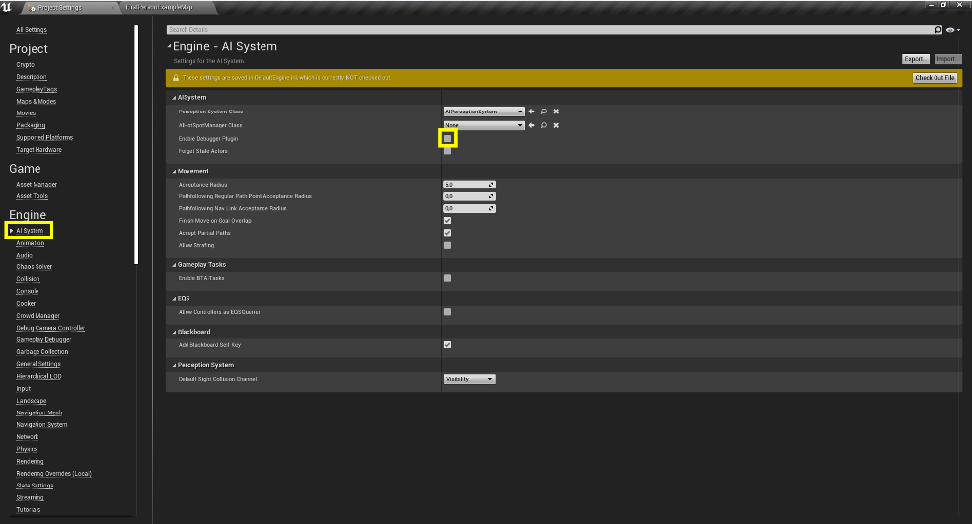
- Enable the AIDebugger (aka Gameplay Debugger). If the debugger is enabled but not working, it is likely caused by a double mapping of inputs on certain keyboards. In this case go to Editor Preferences and make sure the inputs for the ‘console’ and the ‘debugger’ are unique.

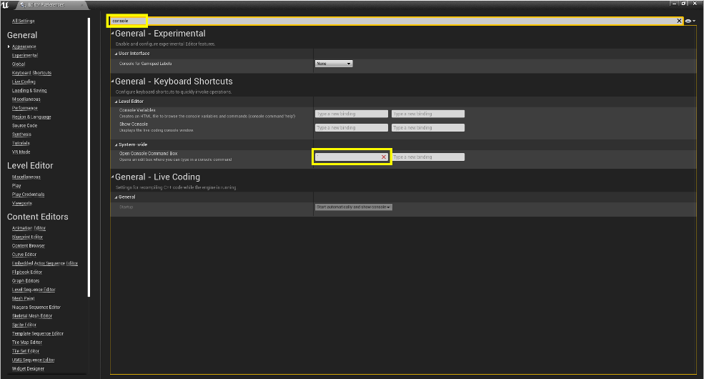

How To Add An AI

Folder Structure and Base Assets
First set up the following folder structure:
Content/
<<AIName>>/
AI/
BTAssets/
EQS/
Detection/
LD/
Rulebooks/
Assets/
For new AI we use the Osakabe as a base. Create the following blueprints, name and folder them.
- A Character blueprint called ‘AI_<<AIName>>’ inheriting from AI_Osakabe.
Into Content/<<AIName>>/
- An AIController called ‘AIC_<<AIName>>’ inheriting from AIC_Osakabe.
Into Content/<<AIName>>/
Go back into the character and set it to use the newly created controller!
- A Behaviour tree and Blackboard called ‘BT_<<AIName>>’ and ‘BB_<<AIName>>’ respectively.
Into Content/<<AIName>>/AI/
The basic AI is now created. Use the remaining folders appropriately when creating assets.
Content/<<AIName>>/
Place no additional assets in this folder.
Content/<<AIName>>/AI/
Use this folder is for high level AI assets such as the behaviour tree and blackboard. Try to keep this folder reserved for the bog overarching assets.
Content/<<AIName>>/AI/BTAssets/
All new Behaviour tree assisting assets should be placed in here. Such as tasks, decorators and services.
Content/<<AIName>>/AI/EQS/
Every new asset related to EQS will be placed here (EQS, Generators, Contexts, etc.). If this folder gets filled up to much create sub folders to separate the assets by type and keep it clean.
Content/<<AIName>>/Detection/
Detection Assets go in here. Expected assets here are those such as the detection rate modifier curve.
Content/<<AIName>>/LD/
This folder is meant for sub-actors to be used by level designers. This folder should only contain the level ready objects, if those need additional assets place them in their own folder.

Content/<<AIName>>/Rulebooks/
This folder is exclusively reserved for inherited rulebooks. No additional files should be placed here.
Content/<<AIName>>/Assets/
Folder reserved for additional assets such as those made by VA.

Set Up Movement
Once you’ve created the AI character BP you’ll be able to configure its movement variables in accordance to its ‘gait’ state.
- When you first open the new character you’ll find the movement settings in the ‘class default’ details panel in its own ‘movement’ category. 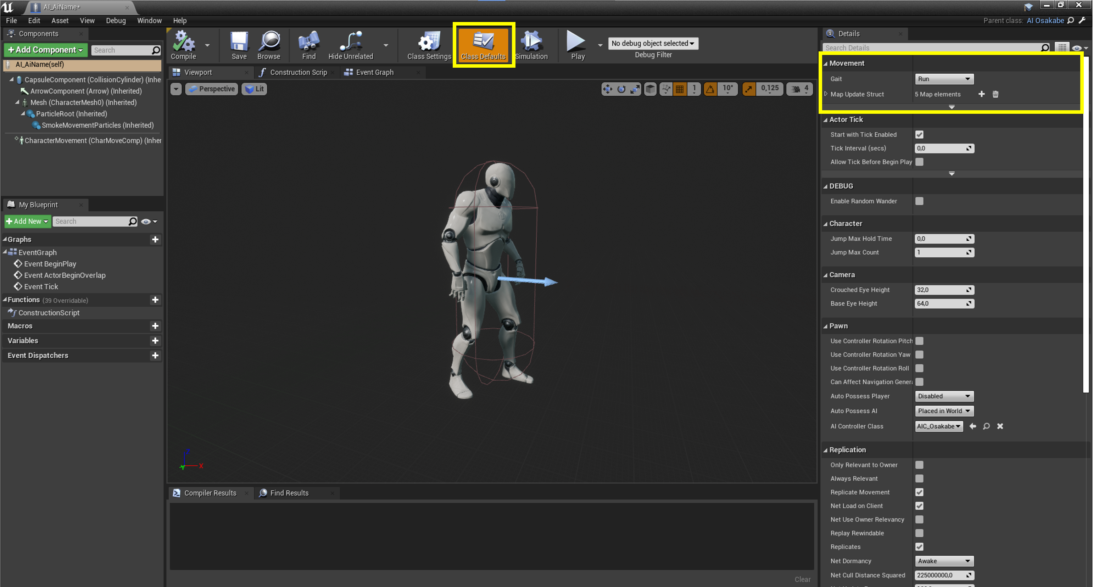
- The first option is the ‘Gait’. This is the default state that gets set when the character gets possessed by a controller. You can set this to your needs however the ‘gait’ is mainly controlled by the behaviour tree meaning this value will likely immediately get overridden. 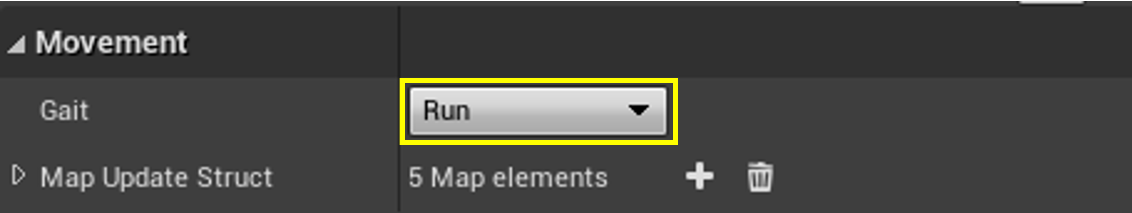
- Each of the different ‘gait’ options relates to it’s own ‘Rulebook’. 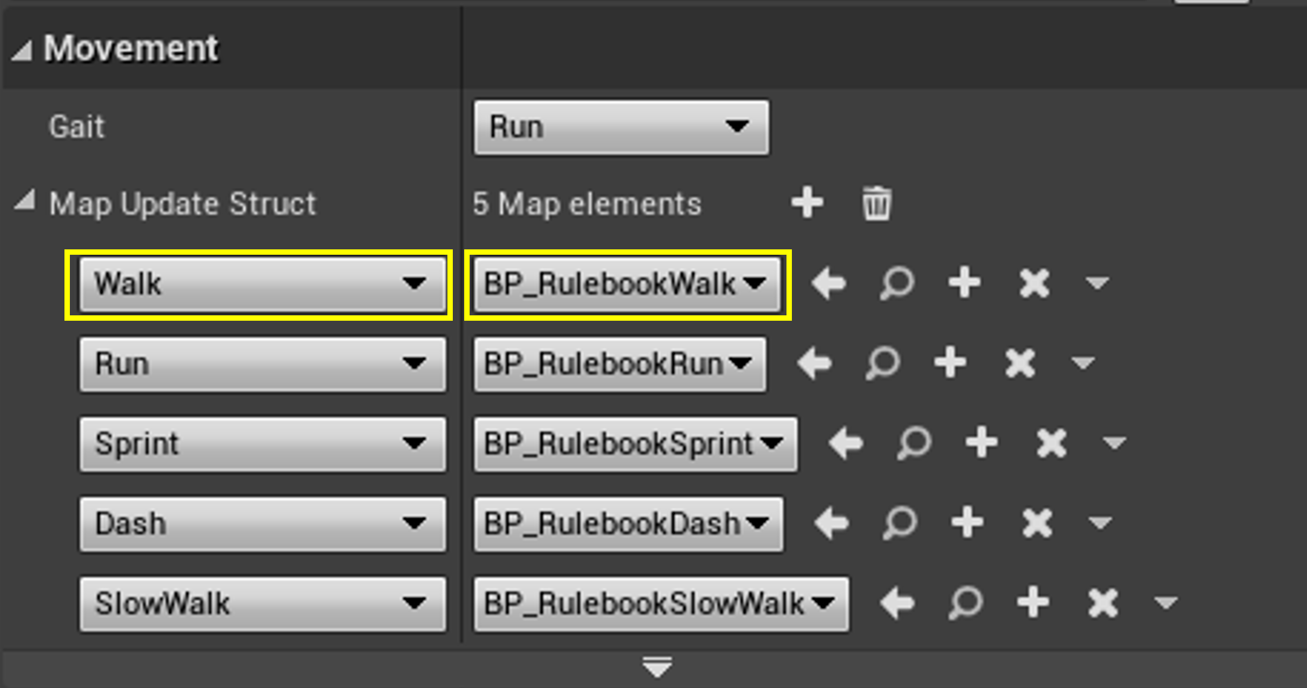
- To configure the variables for each ‘gait’ you’ll work in the according ‘Rulebook’. By default these are set to the ‘rulebooks’ for the Osakabe. You can opt to keep those or create your own for the new AI. (EDITING WILL CHANGE RULEBOOK FOR ALL USING AI)!
- To create your new ‘Rulebook’, click the ‘+’ button. 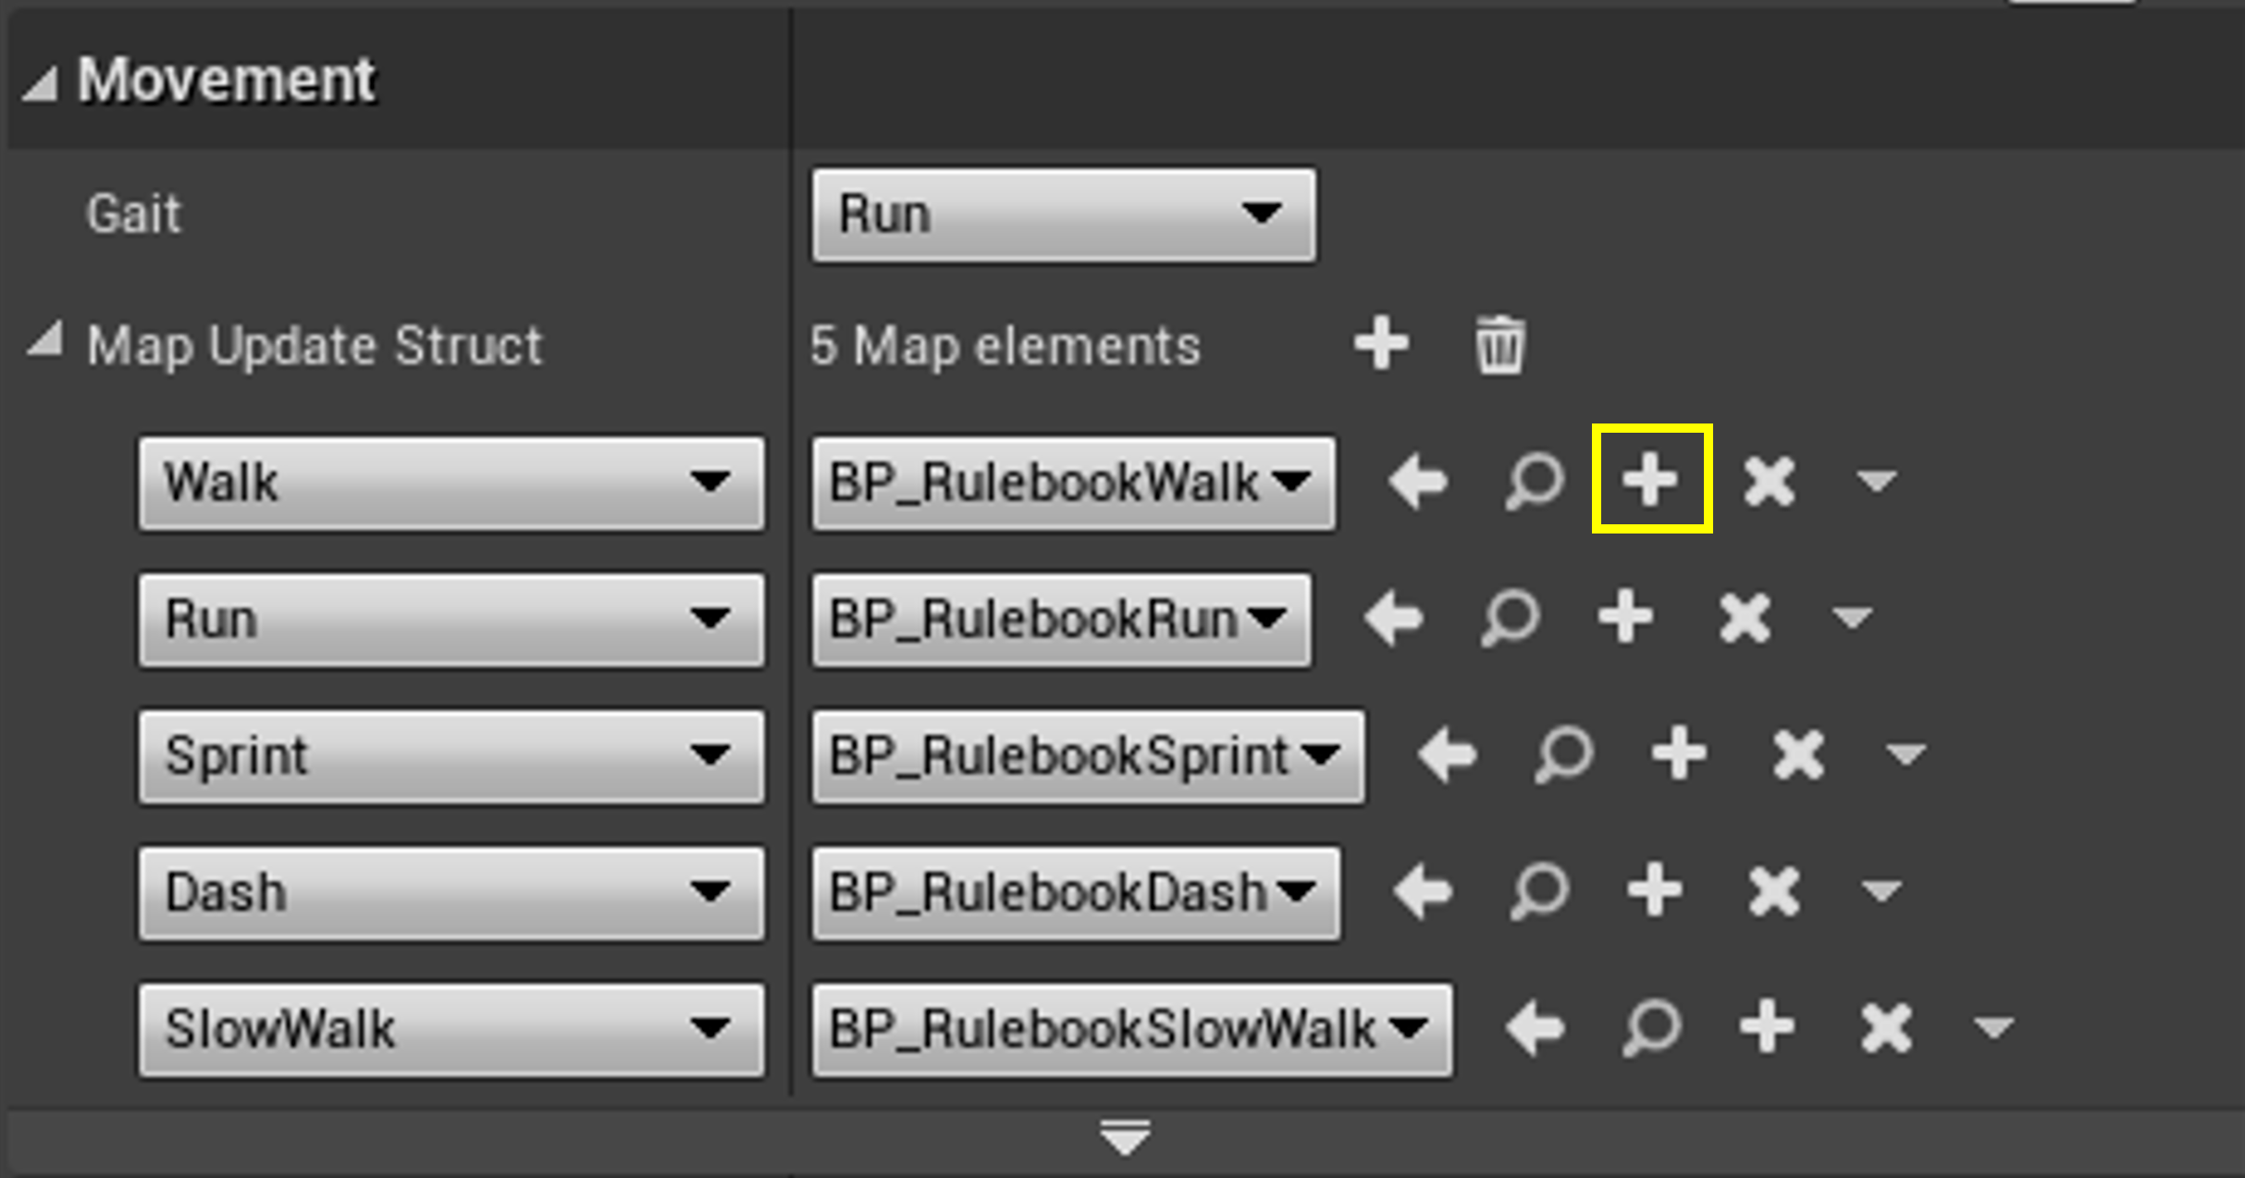
- In the window that pops up, select the ‘rulebooks’ folder for the relevant AI. Name the new ‘Rulebook’ RB_<<AIName>>_<<Gait>>. 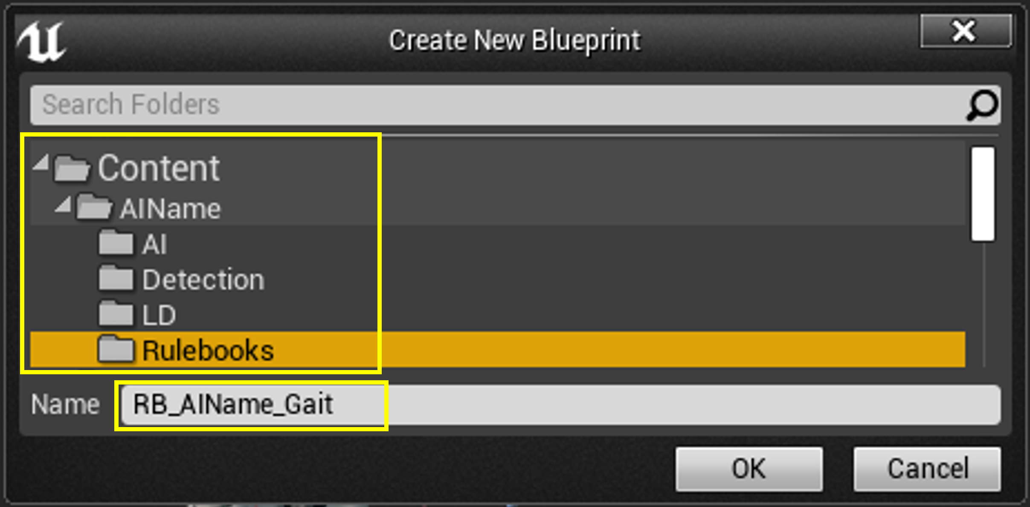
- The new blueprint should automatically pop up. (If it doesn’t look like the image below, close it and re-open it again. It should then recognize it as a data-only blueprint). All the tweakable vallues can then be editied in the ‘Default’ section. 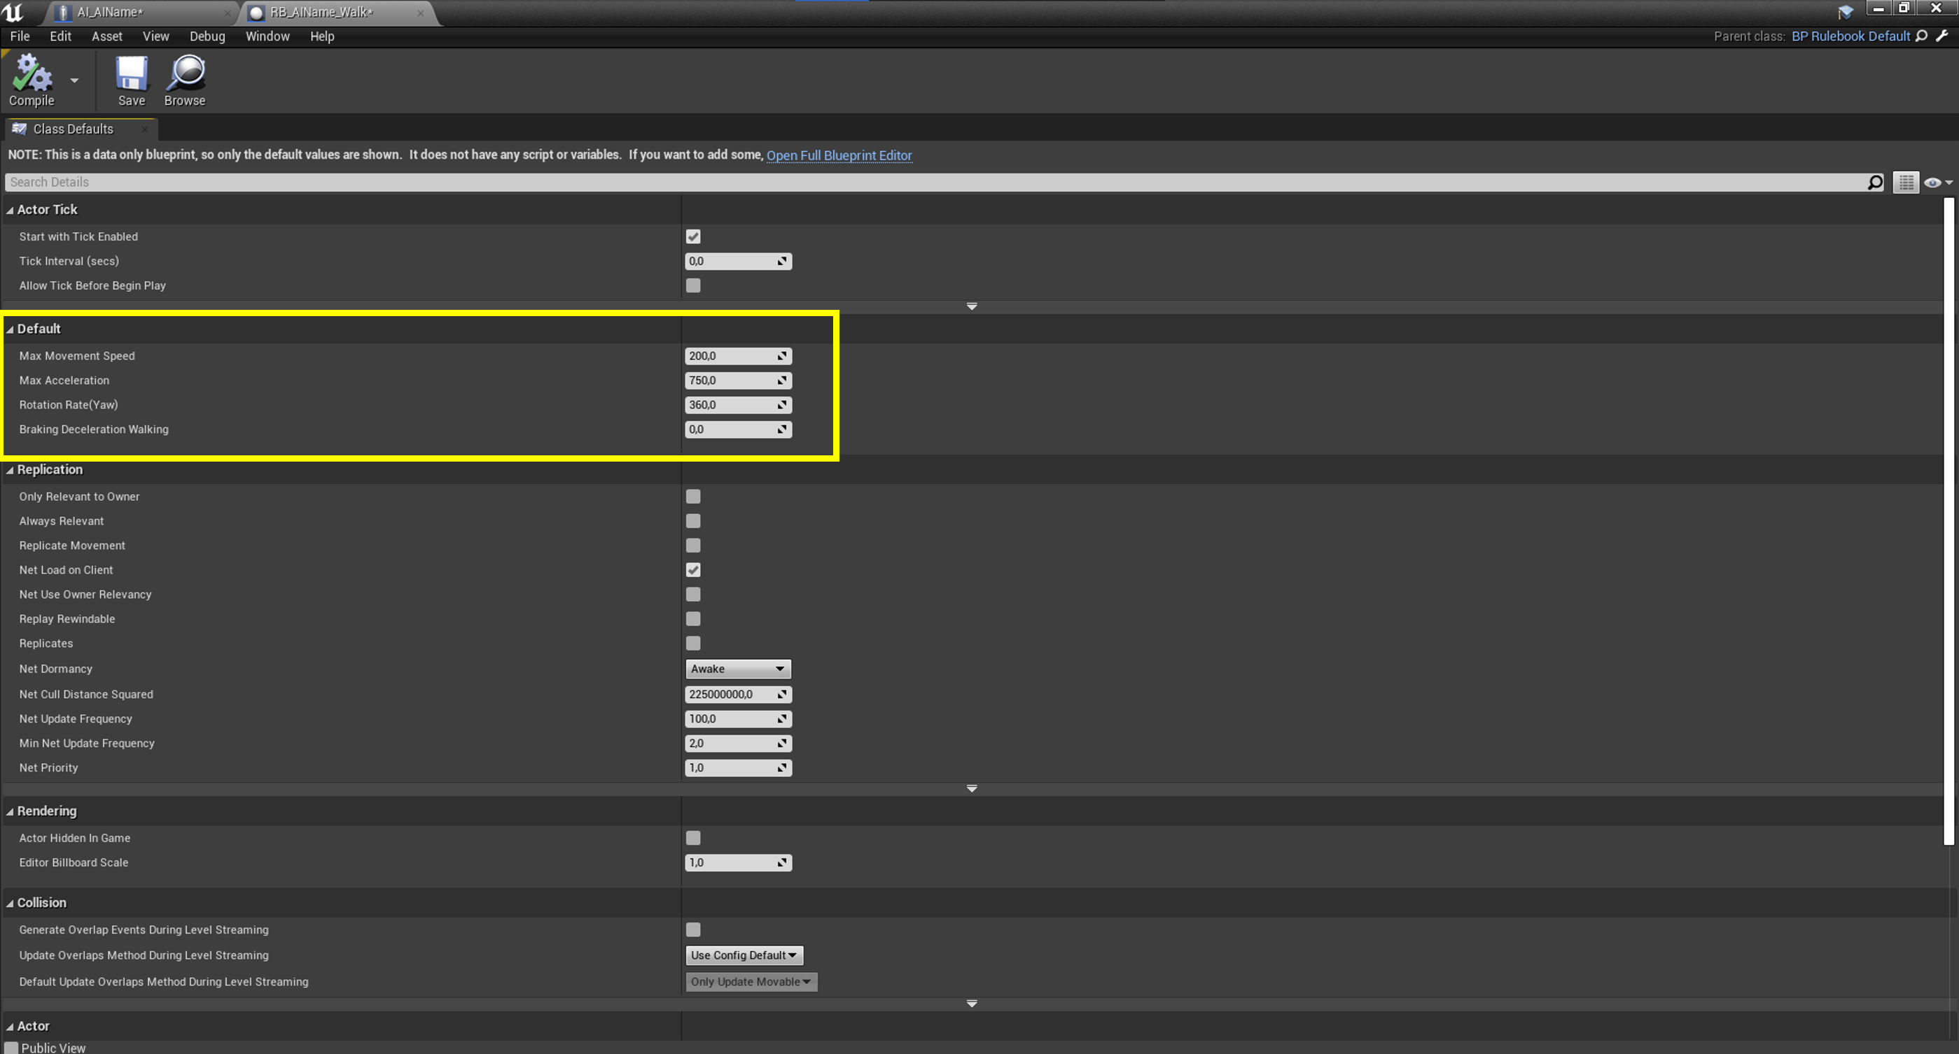
- The AI should now have its new ‘Rulebook’ linked to its ‘Gait’. To test this, drag the AI_AIName into a level and in the details panel enable ‘EnableRandomWander’. This will make the AI randomly roam around in its default gait (see step 2). 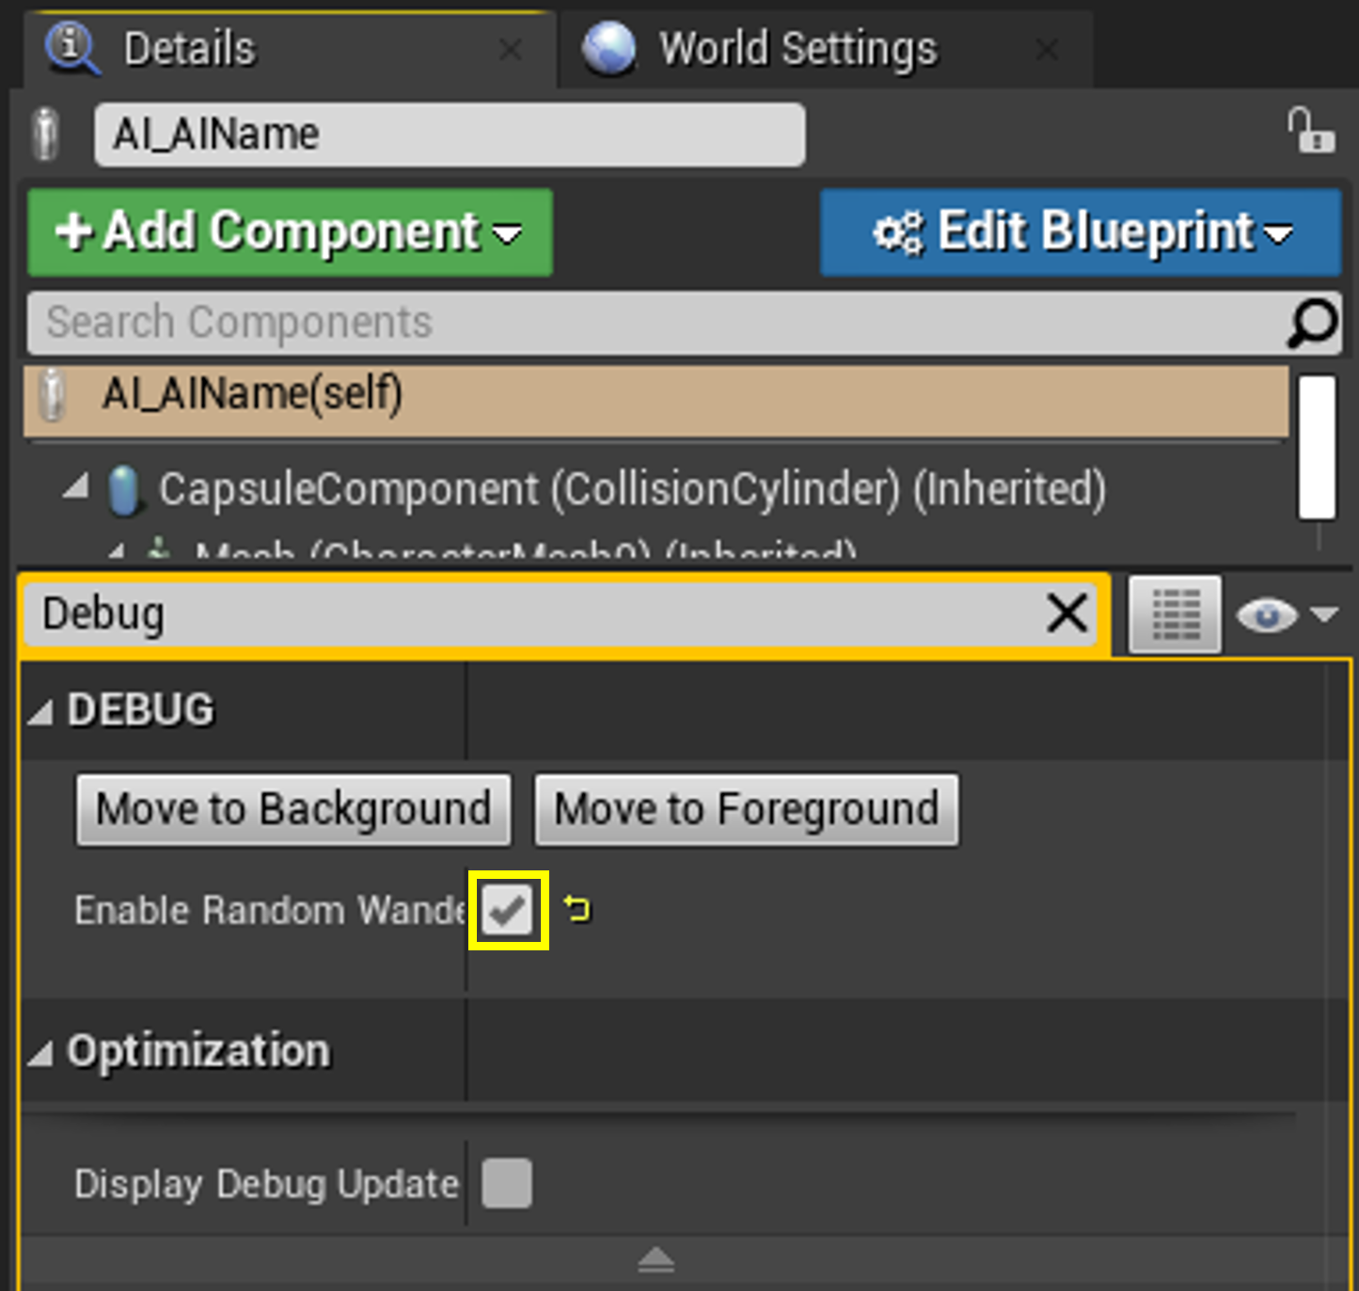
- In the case of not all variables being present, you can expand on the ‘rulebook’. First open the struct located in: Content/Osakabe/Rulebooks/Core/…
- Click ‘New Variable’ then name it, set the date type and set its default value (this value is used by all ‘rulebooks’ if the value here should be generic so it doesn’t alter any other actors use the rulebooks!) 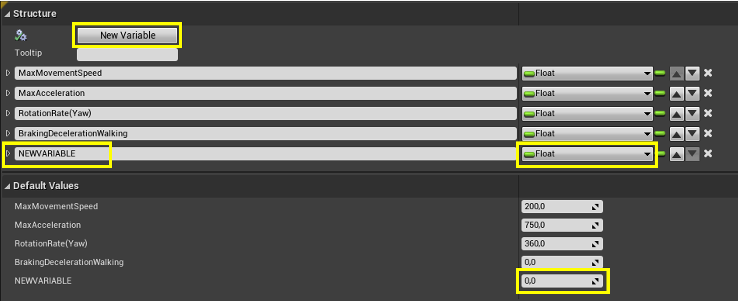
- Now open BP_RulebookDefault placed in the same folder. In here your newly added variable should be visible as an empty pin. ‘Promote to variable’ and name it. Make sure it is instance editable. 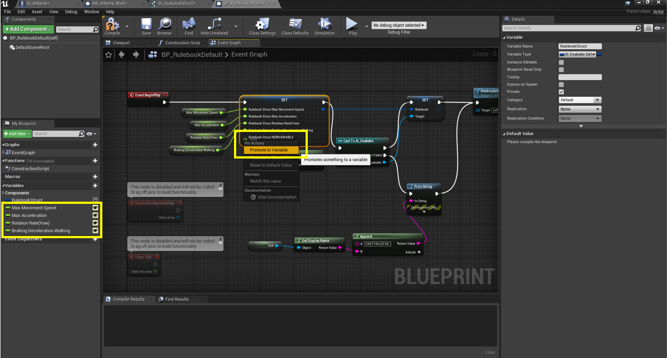
- The third and final step is to make sure the AI actually uses the variable. Open the AI_Osakabe and find the ‘UpdateRulebook’ macro. Then use the value of the struct to set the desired variable. 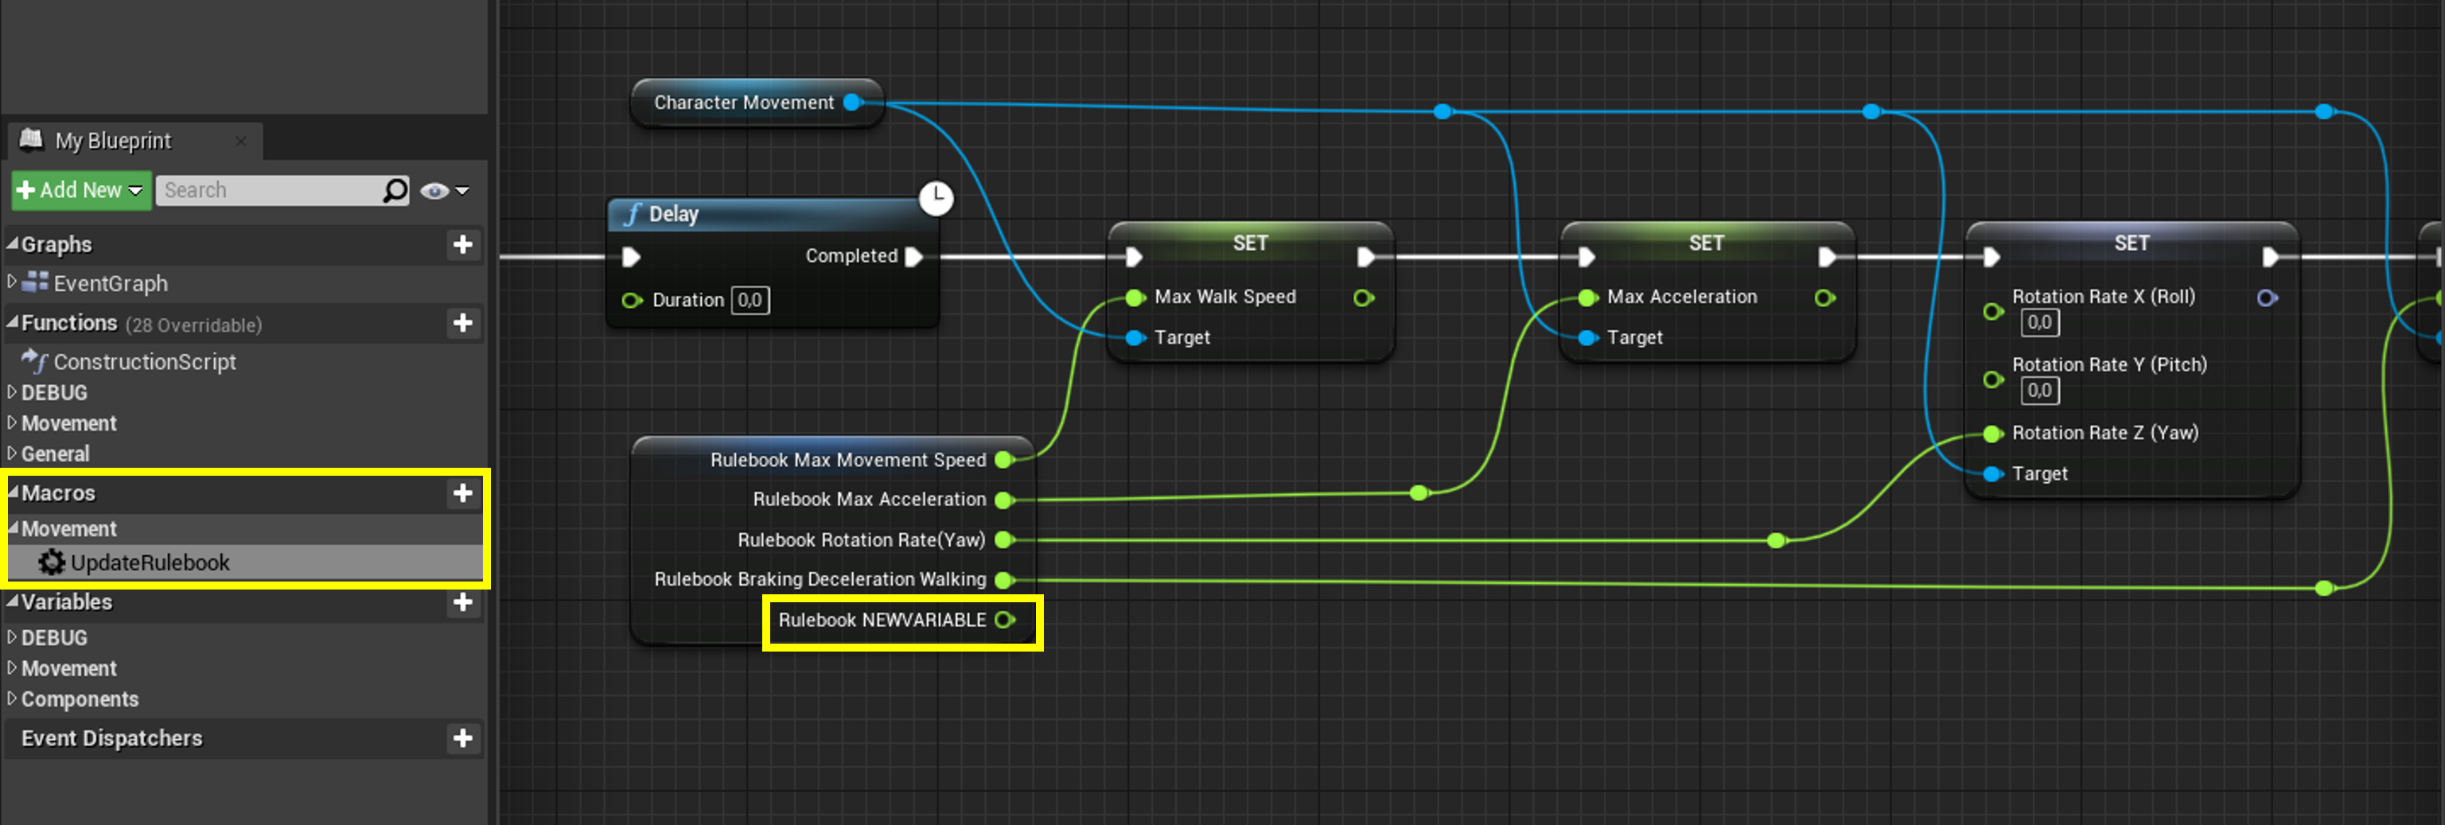
- Note: although this setup seems a bit like overdoing it, it does make sure all values will always get set as desired. Everything now just has to call ‘UpdateRulebook’ instead of setting each variable manually making it prevent oversight and more ‘fool proof’.

Set Up Detection
This set up of detection will only cover the configurable aspects you’ll have access to when an AI is created. It will not cover the creation of new senses as this will require C++ and the project is currently set up as blueprint only.
- Open your AIController (inherited from AIC_Osakabe). In the Class Defaults you’ll be able to set the base detection rate as well as the modifier curve for this value based on distance. You can likely leave it be but if you need to edit these, this is where you’ll find them. 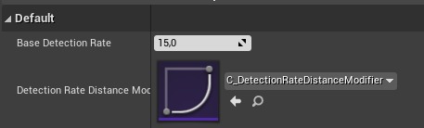
- To specify their actual senses you’ll need to work in the details panel of the ‘AIPerception’ component. 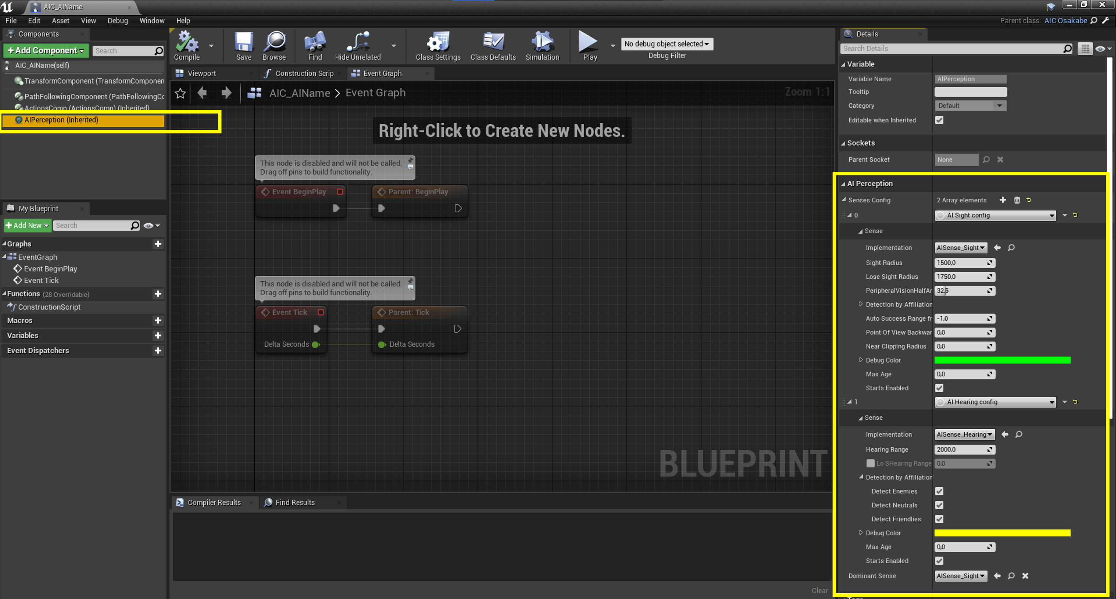
- The following image is taken from Unreal’s official documentation. Follow this link for more. 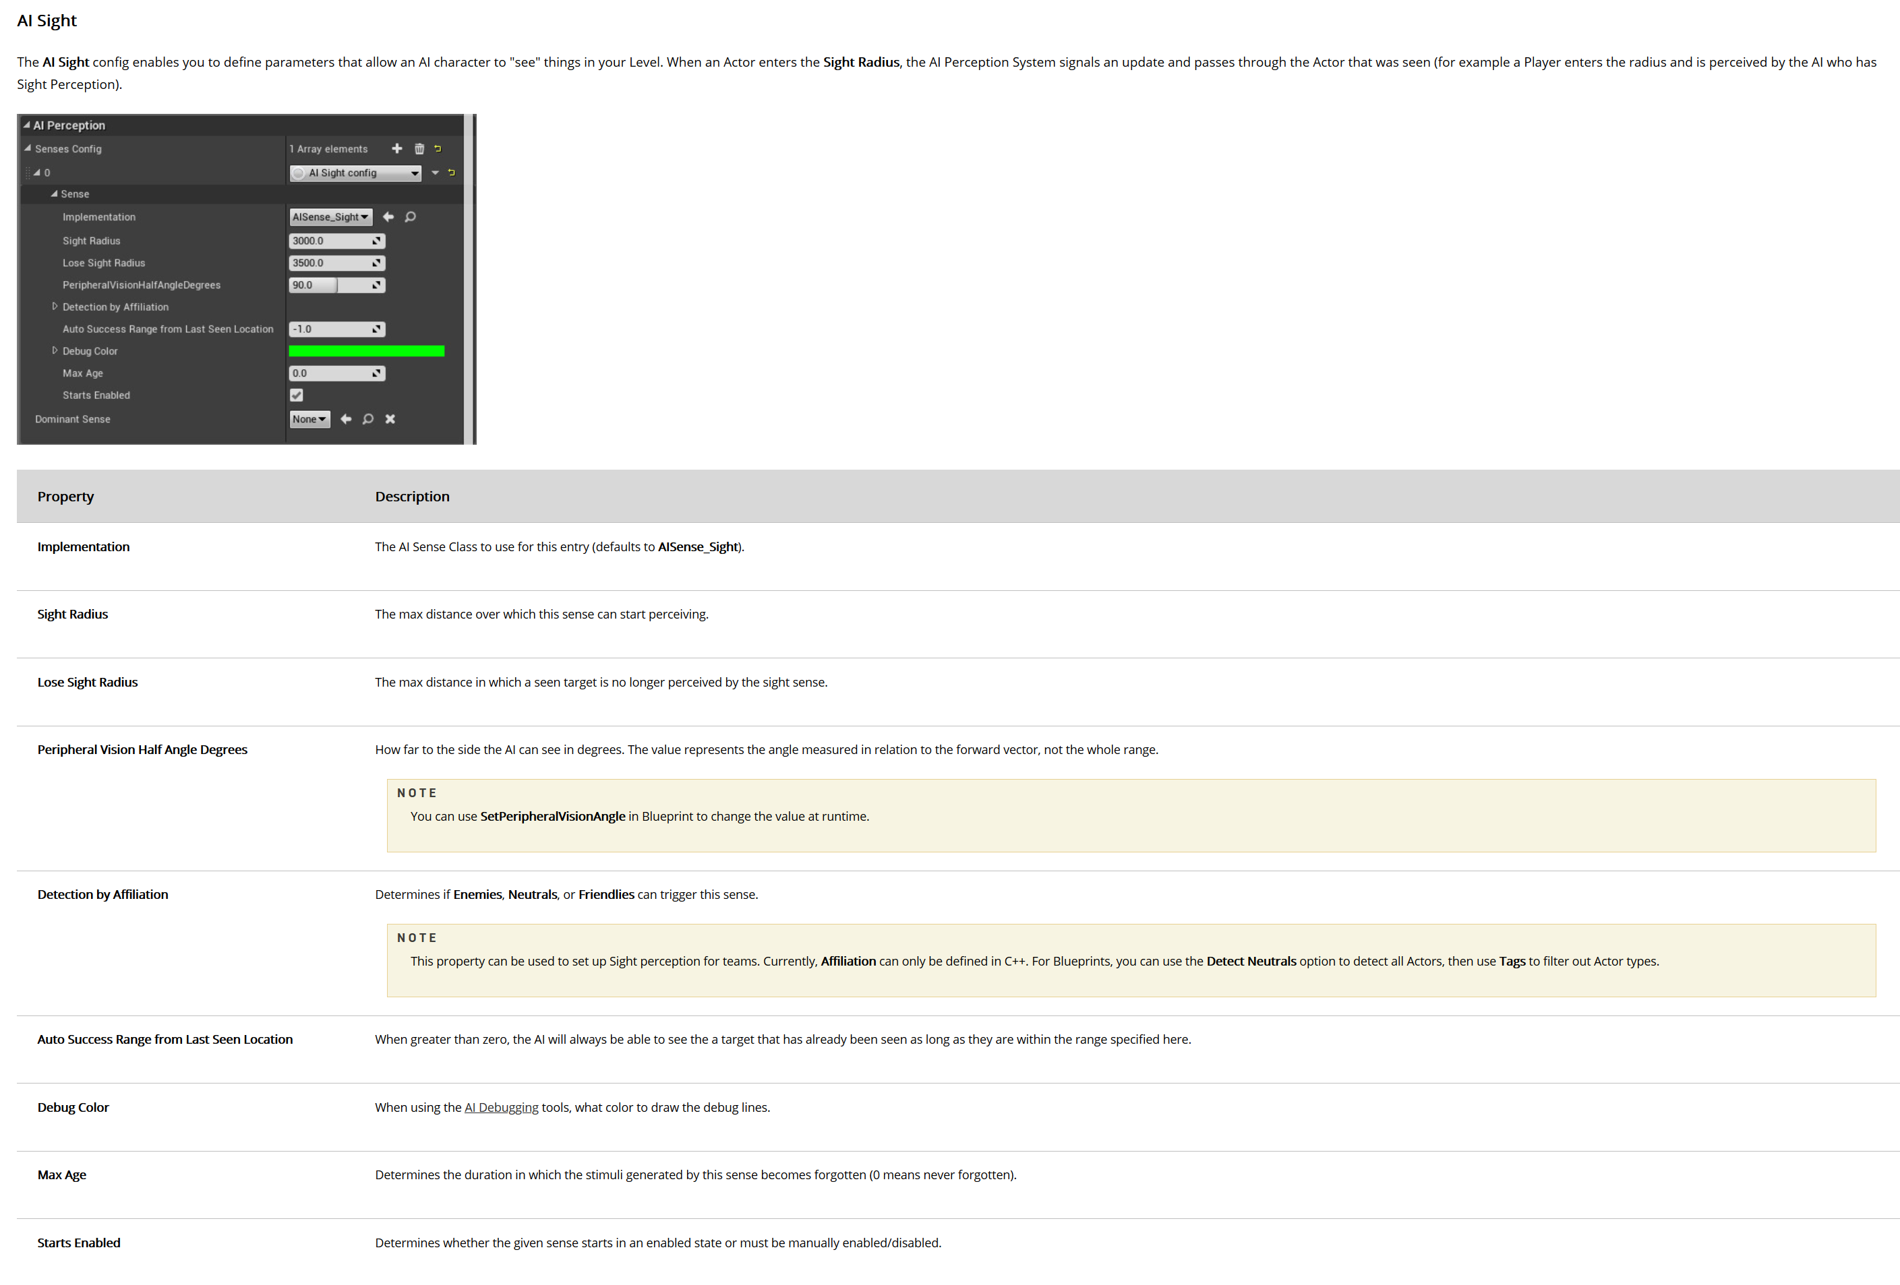 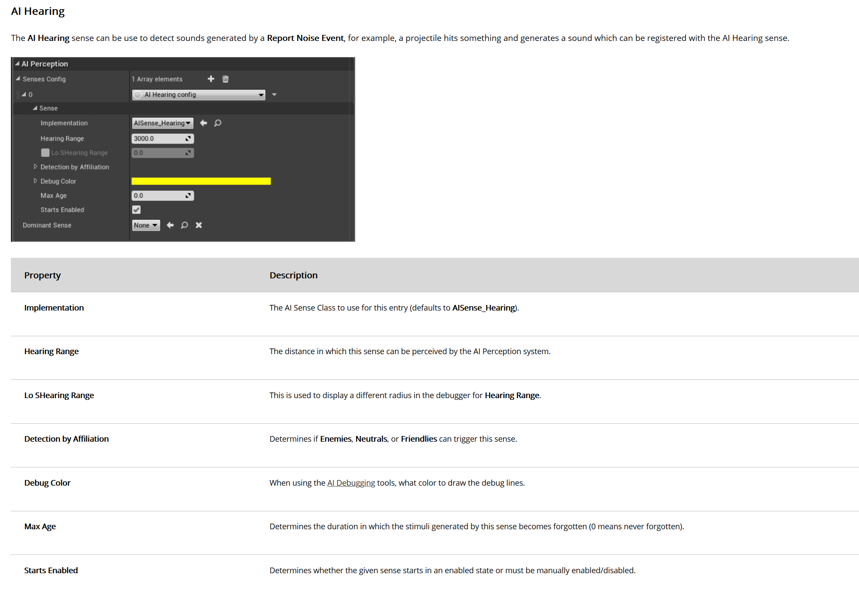
- Please be aware the the AIPerception component is not fully opened up to blueprints. For this reason do NOT change the team affilition setting unless using C++ to set them up first. 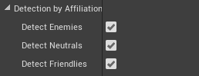
- If the ‘house rules’ were followed then you should be able to use the gameplay debugger while working on perception. If you’re unfamiliar with using this follow this link to Unreal’s official documentation to get started!
- NOTE: due to the earlier limitations with AIPerception in blueprints you’ll have to set the hearing range value twice! Once in the section of step 1 and again in the section of step 3. These values should be exactly the same!

Set Up Behaviour
Next we’ll set up the start of the behaviour tree and blackboard. At the end of this set up the won’t be any behaviour yet but all the keys and states will be set up.
- Open the newly made behaviour tree for the AI and link it up with the appropriate blackboard. 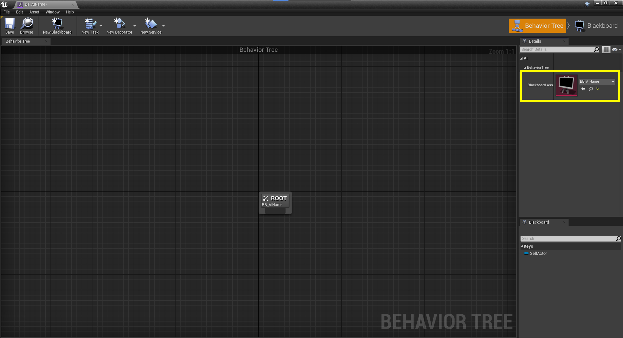
- Now open the blackboard and create and name the following keys (copy the names to avoid spelling mistakes). With all these keys set in place, the information from the detection system will be available to you in the behaviour tree.
TYPE | NAME | Description
Vector | TargetLocation | Runtime function to store location for ‘MoveTo’ after set by an EQS for example.
Bool | InBackground | Whether actor is in the background
Bool | InBackgroundDesired | Does actor want to be in background
Enum (of type E_AlertState) | AlertState | AI state based on detection
Vector | PerceivedLocation | World location of latest perceived stimuli by Detection System
Object (of type Actor) | PerceivedActor | Actor Reference of latest perceived stimuli by Detection System
Object (of type Actor) | PlayerActor | Direct reference to Player Character
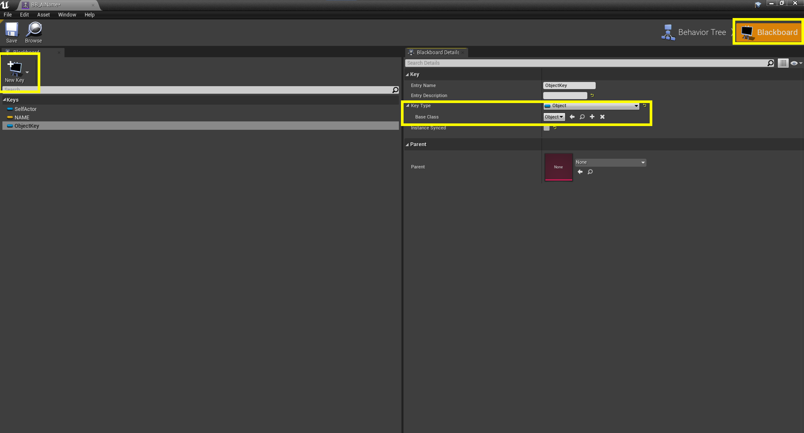
- After all of those are added, go back to the behaviour tree and from the root place a selector and name it ‘StateSelector’. (Naming will help with debugging, if everything is name ‘selector’ you’ll have no idea which one is actually referenced). 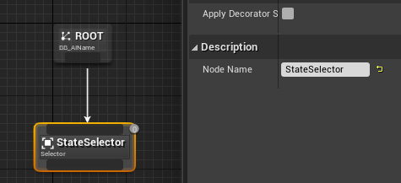
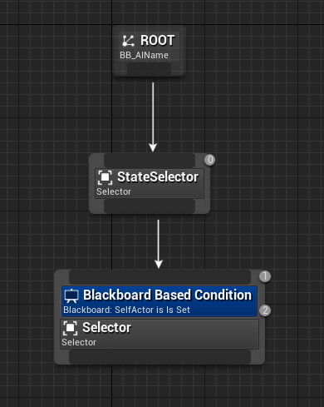
- From the StateSelector, drag and place another selector. Right click on the new selector and ‘add decorator’ of type ‘blackboard’.
- Select the decorator and set ‘Observer aborts’ to ‘Self’; set ‘Blackboard Key’ to ‘AlertState’. 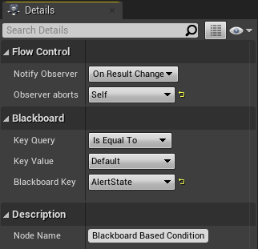
- Duplicate this selector so you have four of them, name each after one of the alert states. Make sure all are connected to ‘StateSelector’. 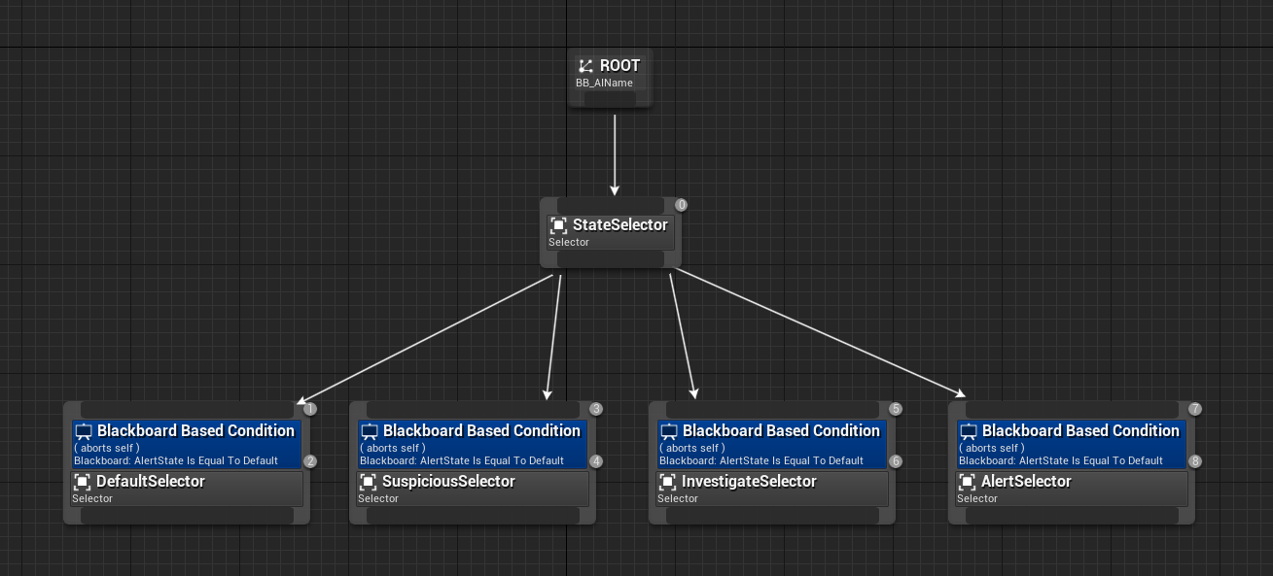
- For each of them, select the decorator and set ‘Key Value’ to the same state as the selector is named. 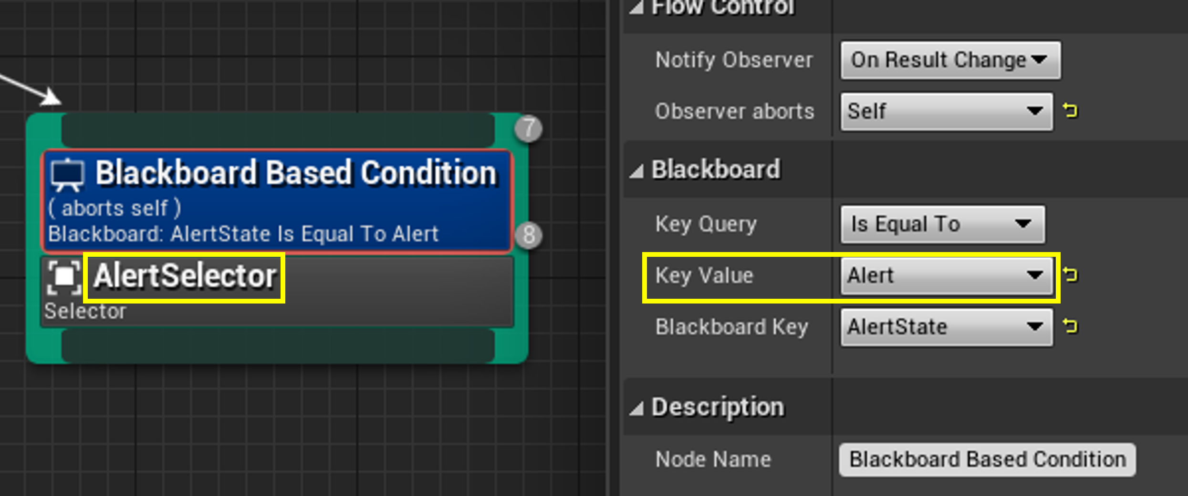
- From here the set up is finished. Each selector is now used for a specific alert state, from there you will be able to build the behaviour. You may use Unreal Engine’s official documentation to proceed from here.
- NOTE: This documentation is created before the Director AI is fully developed. If you’re following this document and the Director AI exists, you should refer to its pipeline to ensure your new AI complies and works with the director AI now.

Good To Know

Level Layers and Navigation
The levels are split up in two areas, foreground and background. The Nav-Mesh inbetween the two layer is ALWAYS marked as ‘obstacle’ and is also the only thing marked with this. You can use this for testing world locations compared to the AI with several Nav-Filters.
‘NavFilter_OsakabeDefault’
This filter scores the obstacle as a path cost of 10000. Because of this value you can use it as a filter. Anything lower then 10000 will be in the same layer as the AI while everything above 10000 will be in the other layer.
‘NavFilter_NeclectObstacle’
This filter scores the default and obstacle areas the exact same way. This is useful to test the actual cost, this way, going in and out of the background can be cheaper then walking around because it doesn’t cost 10000 to enter. Use this to get the optimal path when the level layer doesn’t matter.
‘NavFilter_NullObstacle’
This filter excludes the obstacle areas from the navigable area. This can be used as a simpler version of the first filter. In this case you don’t have to test because all points in the other layer will be unreachable. Do not this limits the information you can get, anything in the other layer ‘doesn’t exist’.
The background entrances have a component called ‘background destination’. This point is always in the background side of the entrance. Use these points as target locations to move not just to the door but past them.

Director AI
Caution, Director AI is not fully implemented yet at the time of writing. If you’re reading this and the Director AI has been further developed, please use it’s own documentation and consider this deprecated. [12/04/2021]
The director AI handles some parts of the Osakabe and game in general. Although there may not be too much there, the Director AI does store all of the player’s objective (and specifies their current one). You can use that as reference of where the player will be/where the AI should roughly be.

Points Of Interest
With Point Of Interests the level designers are able to mark interesting points in their levels. You can consider them patrol points. The actors can be found with the tag ‘POI’. Use this to patrol around, for example pick three ‘POI’ locations near the player’s objective.

